Ideation Phase
Define the Problem Statements
Date | 27-09-26
Team ID | 23KD1A4230
Project Name | Metro Ticket Generating System in ServiceNow
Maximum Marks | 2 Marks

Customer Problem Statement:
Daily metro commuters face long, stressful wait times just to buy a ticket during rush hour. Because the stations rely heavily on manual cash transactions and paper tickets, people are forced to stand in slow-moving physical lines. This outdated process not only makes travelers anxious about missing their trains, but it also causes frustration when small paper tickets or tokens get lost or damaged before they even reach the boarding gates.
At the same time, this manual system creates huge problems for the metro management team. Station staff easily become overwhelmed during peak times, leading to errors and crowd control issues. Furthermore, relying on physical tickets means the organization has high operating costs, wastes a lot of paper, and completely misses out on collecting valuable digital data to understand passenger travel habits and improve train schedules.
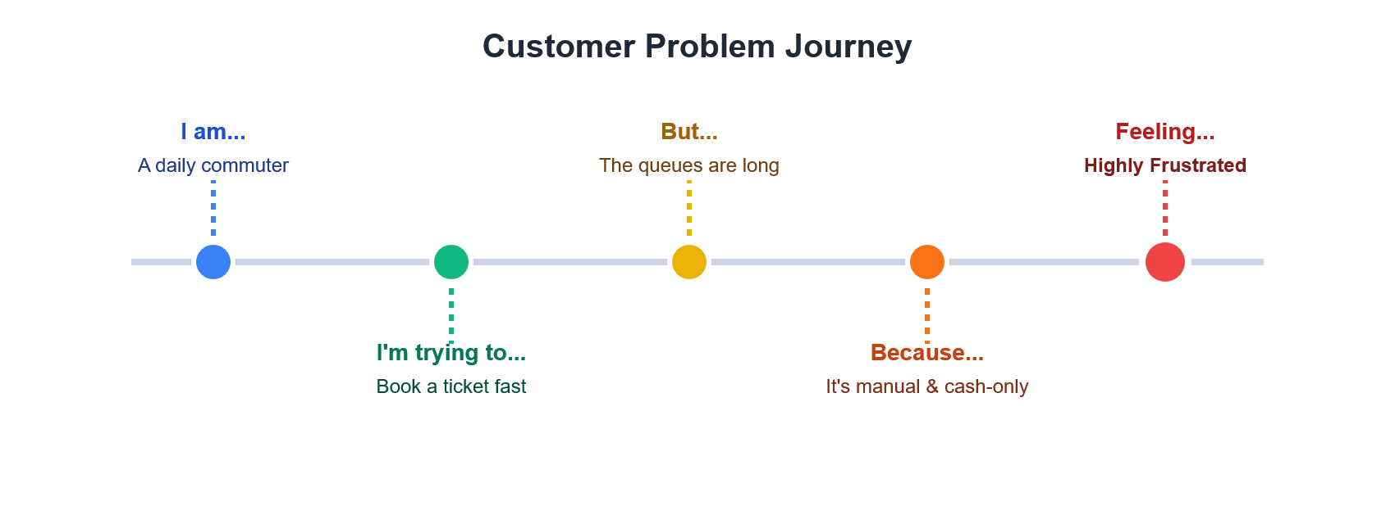
Problem Statement (PS) | I am (Customer) | I'm trying to | But | Because | Which makes me feel
PS-1 | A daily metro commuter | Book a metro ticket quickly during rush hour | I am forced to stand in a slow-moving physical queue | The station relies on manual cash transactions and paper ticket issuance | Frustrated, stressed, and anxious about missing my scheduled train
PS-2 | A metro station manager | Ensure smooth passenger flow and efficient revenue collection | My staff gets overwhelmed during peak travel times | We lack an automated digital fare calculation and mobile ticket validation system | Overwhelmed and highly concerned about operational errors and delays

